# Class 1

## Discuss the following

1. The Game Loop
2. Objects
3. Functions

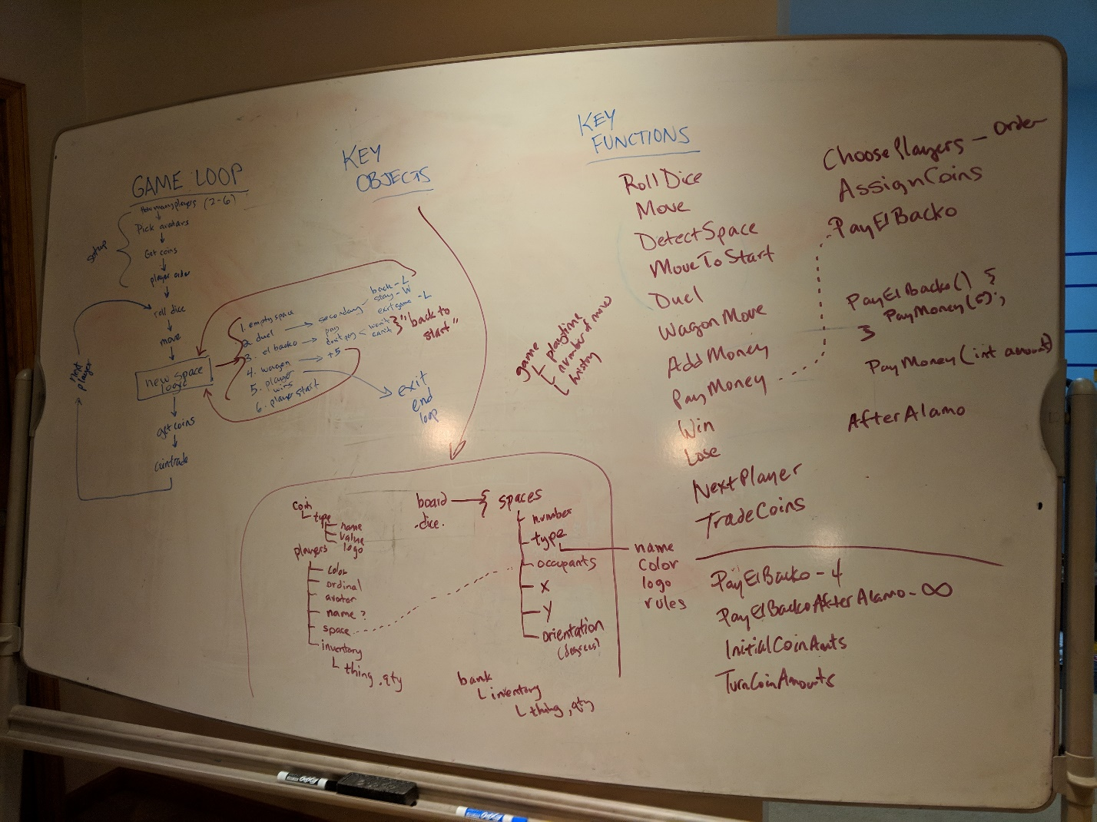

# Homework 1.1

## Setting up NodeJS

Tasks

1. Install NodeJS
2. Install Sublime Text 2 (not Sublime Text 3)
3. Do a Pull in SourceTree
4. Install npm modules  
     
   * Open Command Prompt  
   * cd\Dev

* cd elbacko  
* npm install dict  
* npm install readline-sync  
  
Notes: you will see some warnings when you do the two npm commands. You can ignore them.

1. Try some node programming  
     
   * Open Command Prompt  
   * cd\Dev

* cd elbacko  
* node  
  
> 5

5

> Math.max([5,4,3,1,9,10]);

NaN

> Math.max(5,4,3,1,9,10);

10

* Press Ctrl+C  
* Press Ctrl+C again

# Homework 1.2

## Node modules

Make a folder in c:\dev\elbacko – your name.

Create three files in Sublime Text 2, all within c:\dev\elbacko\[your name]:

**File 1.** spaceTypes.js

function SpaceType(name, size) {  
 this.name = name;  
 this.size = size || 1;  
}  
module.exports = SpaceType;

**File 2.** space.js

function Space(number, type) {  
 this.number = number;  
 this.type = type;  
}

module.exports = Space;

**File 3.** game.js

var spaceType = require('./spaceType.js');

var board = [];

// lay out the board

for (var i = 0; i < 10; i++) {  
 var newSpace = new space(i);  
 if (i == 0) {  
 newSpace.spaceType = spaceTypes.get("start");  
 } else if (i == 6) {  
 newSpace.spaceType = spaceTypes.get("elbacko");  
 } else {  
 newSpace.spaceType = spaceTypes.get("normal");  
 }  
 console.log("Space " + i + ": " + newSpace.spaceType.name);

board.push(newSpace);

}

**Try running your script.**

c:\Dev\elbacko\[your name]>node game.js

# Class 2

## Discuss the following

* GitHub Push, Pull
* The spaceType.js file and SpaceType class
* The “if” statement and the “for” loop for building spaces

Add the three types of space types to the game that are currently missing.

Stage, Commit, and Push your changes.

If a Push doesn’t work, do a Pull first.

# Homework 2.1

## Build the Board

Tasks

1. Update the for loop to have enough steps to build the whole board
2. Update the if statements to create the board in the right order and right types of spaces

# Homework 2.2

## Taking Names

Get player numbers

1. Add this to the declarations at the top of game.js

var readline = require("readline-sync");

1. At the end of game.js, add these lines:

var playerCount = readline.question("How many players?");  
console.log("");  
for (var p = 1; p <= playerCount; p++) {  
 console.log("Player #" + p);  
}

1. Try putting in different numbers to the question.
2. Try putting in non-numeric answers and see what it does!   
   (BONUS: how would we fix this? – see <https://www.bing.com/search?q=javascript+check+numeric> )

# Class 3

## Discuss the following

* Revisit GitHub stage, commit, push, pull
* for loops
* Creating a player class: player.js

var dict = require("dict");  
function Player(ordinal) {  
 this.ordinal = ordinal;  
}  
module.exports = Player;

* Load this into game.js
* Loop and list the players
* What other values could a Player have?
* Discuss the dictionary.

# Homework 3.1

## Make bank

The bank is a good use of a dictionary. Let’s make a bank. In game.js, let’s make a bank, just below the declarations part. By where we make the board (var board = []);

var bank = {  
 inventory : new dict({})  
};

What did we make? It’s a variable called bank, which is an object that has one property: “inventory” and the inventory has a dictionary.

Now go down to where you put in the number of players, and right above that, let’s create the bank’s inventory.

// create the bank  
bank.inventory.set("silver", 120);

Also add gold to it. Let’s have it start with 35 pieces of gold.

# Homework 3.2

## Tracking players

1. Create a variable at the top where we have the board[] and game{} called players. It will be an empty array.
2. Add each new player to the players array. Inside the loop at the end of your file, where you are creating each player, put this line before the } part of the loop.

players.push(newPlayer);

After this the players[] array will have a copy of each player.

1. Add gold and silver to each person’s inventory.

newPlayer.inventory.set("gold", 5);

Do this within the loop where you are creating the players.

# Class 4

* Look at homework
* Add silver to opening inventory
* Set values in the code for initial gold and silver
* Review syntax of our code

Build a game loop

* Add a player pointer
* Print current player
* Increment pointer
* Start over pointer